Driven Racing Oil™ Diagnostic Wipes Indicate Oil Life
Huntersville, NC – New Engine Oil Diagnostic Wipes from Driven Racing Oil™ take the guesswork out of deciding whether it’s time to change your vehicle’s oil.
The wipes are designed to determine the basicity (TBN) of a small amount of engine oil. Either wipe your dipstick with or drip some oil on the wipe, and then wait a few seconds for the result. If the area saturated with oil turns pink, then the oil still has life and does not need to be changed. Minimal pink after one minute means the oil should be changed soon, while the absence of pink indicates the oil is acidic and needs to be immediately replaced.
Part Number: DR100-23 (3 wipes) Price: $5.00
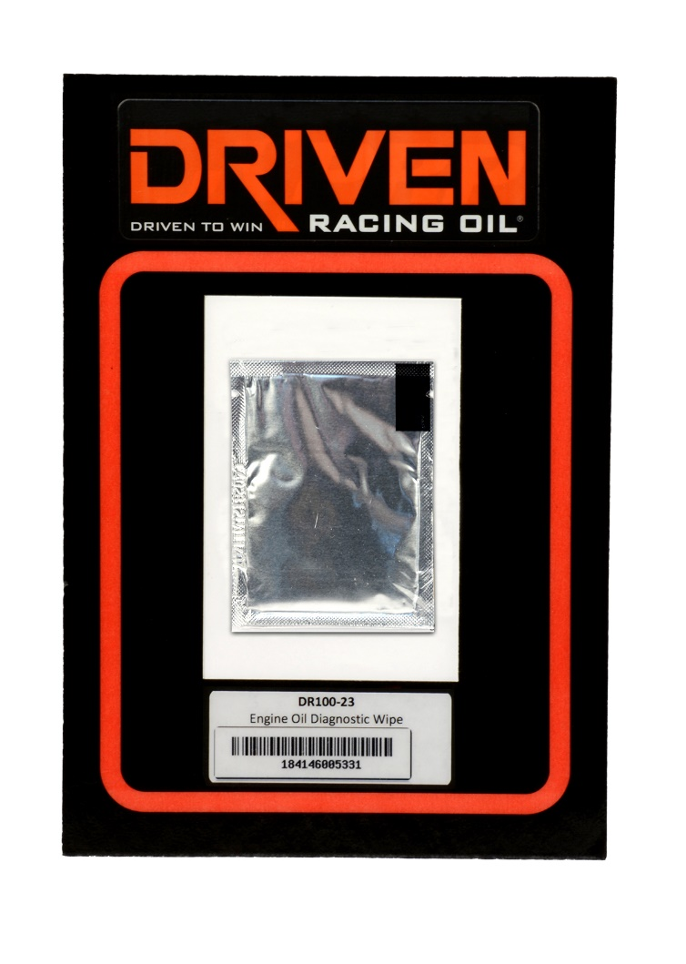
About Driven Racing Oil™
Born from Joe Gibbs Racing, one of the most successful NASCAR teams of the past two decades, Driven Racing Oil™ utilizes cutting-edge lubricant technology and on-track research for maximum performance gains from all of its product offerings. Competition drives innovation, and Joe Gibbs Racing originally developed the Driven brand of oils to advance engine and driveline performance on the racetrack. From full-synthetic race oils to engine break-in oils and cleaners, Driven offers a wide range of race and street products that deliver performance, protection and value.

